Intelligent learning through exercise
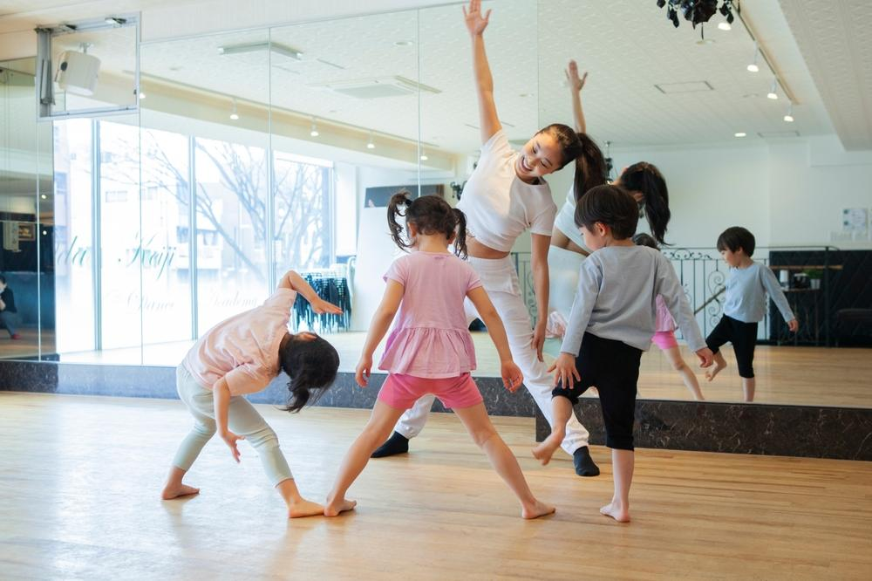

Written by: Fung Ji Hei, Game Therapist

I just participated in a professional development exchange activity for teachers in Taiwan, and witnessed how Taiwan's education system emphasizes using exercise to cultivate children's growth. This has given me new inspiration, and I hope to share it with all parents. One of the schools we visited for the exchange could be called a "mini sports university" - "Tiger Forest Elementary School". As soon as I stepped into the school, the students greeted us with the government-promoted fitness exercises. They followed the rhythm to raise their hands and move their bodies, doing all kinds of warm-up movements. It made me feel like they were as lively as little tigers, and I felt like I had entered a forest full of little tigers.

Exercise Can Strengthen Children's Learning Ability

Principal Liu of Tiger Forest Elementary School said that the school is a key government school focused on the physical development of the students, and believes that exercise can strengthen their learning ability. They are based on the research of John J. Ratey, MD, an assistant professor of clinical psychiatry at Harvard Medical School, and advocate the "Anytime Exercise" program. This program encourages students to exercise at any time. During breaks, students run to any part of the playground to exercise, some play dodgeball, some climb on the jungle gym, and some play badminton. All the students enjoy every moment of exercise.



The Benefits of Exercise - Strengthening Brain Function

It is well known that exercise has the effect of strengthening the body and health. In Ratey's research, he points out more about the benefits of exercise for the brain. He describes the brain as an information processing center, where information is transmitted through different pathways using different messengers (chemicals). During exercise, the brain can effectively produce more messengers and strengthen the pathways, making the transmission of information faster and more accurate.

When applying this theory to learning, students can strengthen their brain function through exercise, thereby enhancing their learning effectiveness. Research has proven that exercise can improve students' concentration and memory, which are essential conditions for successful learning. In addition, exercise can cause the brain to produce Dopamine (a chemical that creates a sense of happiness), allowing students to learn happily, and naturally achieving better results.

How to get children to love exercise?

To let children enjoy the time and benefits of exercise, parents need to help children love exercise. Here are three suggestions:

1. Anytime Exercise

Provide more opportunities for children to exercise, such as giving them appropriate time, tools, and venues, while parents should also pay attention to the safety of the environment.

2. Healthy Exercise

Teach children to exercise for the sake of health, and emphasize the benefits of exercise to health.

3. Exercise Together

Exercise with children more often, enjoy the moments of exercise, and cherish the quality time between parents and children.

