Why do children have the habit of sucking their fingers? What can parents do about it?



Written by: Ms. Chan-Chen Shu-an, Early Childhood Education Specialist

Some children still have the habit of sucking their fingers even when they enter kindergarten, or even at ages 5 or 6. According to Dr. David Levy's research, children who finish a bottle of milk in 10 minutes (possibly due to a larger bottle nipple hole) are more likely to develop the habit of sucking their fingers, compared to children who finish the entire bottle in 20 minutes. Dr. Levy also experimented by feeding puppies with a dropper, so they didn't have a chance to suck while drinking milk. The result was that the puppies reacted by sucking each other's or their own skin, and some even peeled off the skin through excessive sucking. From this, we can understand that the behavior of infants sucking their fingers in the first few months is due to the lack of satisfaction from sucking, it is a need, and not an innate or bad behavior.

Why do children develop the habit of sucking their fingers?

Breastfeeding Promotes Parent-Child Bonding
When a mother can breastfeed her baby, the infant is the happiest, because not only does the baby receive proper nutrition, but also the skin-to-skin contact provides warmth and a sense of security. Moreover, by sucking on the soft nipple, in addition to getting fed, the baby also enjoys the communication and deep love between mother and child. This profound affection and intimacy is incomparable to being fed by a cold bottle. The baby also experiences an unparalleled sense of fulfillment from the sucking.

However, as most mothers have to work outside the home, and for various other reasons, they have to use bottles to feed their children. In these cases, parents should pay special attention to the frequency and time taken for bottle-feeding. Mothers should calmly let the child eat slowly, and pay particular attention to the size of the bottle nipple hole. If the baby's sucking needs are adequately met, they are less likely to develop the habit of sucking their fingers. Babies tend to start finger-sucking unconsciously - their little fingers move around and end up in their mouth, and they find pleasure and satisfaction in sucking on them.



Venting Psychological Stress

However, if the habit of thumb-sucking persists even at the age of 4-5 years old, the meaning is different. This could be a way to vent psychological stress. For example: due to conflicts between parents, the child feels anxious; because of a new sibling, the child fears losing parental love; because parents are too busy and unable to take care of them, the child feels lonely and lacks the warmth of a family; or the child was sent to kindergarten too early and lacks proper care, resulting in a lack of a sense of security. These factors can lead the child to feel anxiety, uneasiness, tension, and panic, which are all causes of psychological stress.

Just like adults, when children experience psychological stress, they need to vent it, which is a very natural phenomenon. Adults often use smoking to relax themselves. Children may use thumb-sucking or rocking to vent their emotional tension. In this case, as parents, in addition to paying attention to improving their attitude towards the child, they should also have extra patience. They should maintain a calm and kind attitude, so that the child can feel relaxed and not under pressure. If the parents show worry, tension or are hasty in correcting the behavior, such as tying the hands or applying bitter medicine, it will only backfire and increase the child's insecurity. The child wants to stop the habit but cannot control it, creating a vicious cycle that prolongs the thumb-sucking habit.

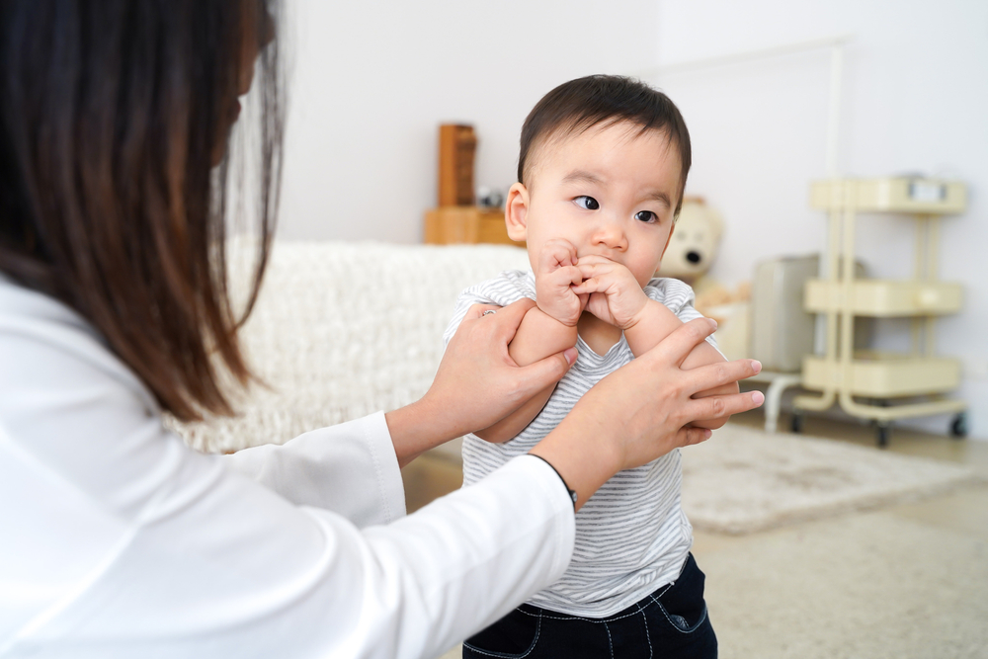

What can parents do?

1. Breastfeed as much as possible, as this is the most natural and suitable feeding method for infants, and it reduces the chances of the child developing a thumb-sucking habit.

2. When using a bottle to feed the child, parents should pay special attention to the feeding time, and aim to maintain the feeding for 15 to 20 minutes, which is relatively ideal.

3. Use toys and dolls to engage the child in finger activities, in order to divert the child's habit of thumb-sucking.

4. Spend more time with the child, playing together, telling stories, and singing children's songs, so that the child does not feel lonely and bored, and thus less inclined to suck their thumb.

5. When the child sucks their thumb excessively, parents should still be patient and maintain a calm and relaxed attitude. Sometimes, ignoring the behavior and not drawing attention to it can naturally lead to the disappearance of the thumb-sucking habit.

6. If the child has had a thumb-sucking habit for many years before the age of 6, it will gradually disappear, especially when the child no longer sucks their thumb during the day, but only while sleeping. Parents should be patient and wait, as rushing to correct the habit is ineffective. Particularly after the child starts kindergarten, the habit may disappear naturally, as the child may not want to suck their thumb in front of their peers, or they are too busy with other activities at school.

7. Sucked fingers can have an unpleasant odor. If a child aged 5-6 still has the thumb-sucking habit, parents can try having the child smell the unpleasant odor, which may help correct this bad habit.

